

EARTH AND ENVIRONMENTAL SCIENCE SAMPLE EXAMINATION

Section 7 of the New WACE Manual: General Information 2006–2009 outlines the policy on WACE examinations.

Further information about the WACE Examinations policy can be accessed from the Curriculum Council website at http://newwace.curriculum.wa.edu.au/pages/about_wace_manual.asp.

The purpose for providing a sample examination is to provide teachers with an example of how the course will be examined. Further finetuning will be made to this sample in 2007 by the examination panel following consultation with teachers, measurement specialists and advice from the Assessment, Review and Moderation (ARM) panel.

0000.doc




Sample Examination

Question/Answer Booklet

EARTH AND
ENVIRONMENTAL
Please place your student identification label in this box
SCIENCE

Student Number: In figures

In words

Time allowed for this paper
Reading/planning time before commencing work: Ten minutes
Working time for paper: Three hours

Material required/recommended for this paper

To be provided by the supervisor
This Question/Answer Booklet

To be provided by the candidate
Standard items: Pens, pencils, eraser or correction fluid, highlighter, ruler, printed English language dictionary and/or bilingual dictionary (non electronic and not a thesaurus)

Special Items: Calculators satisfying the conditions set by the Curriculum Council for this course.

Important note to candidates
No other items may be taken into the examination room. It is your responsibility to ensure that you do not have any unauthorised notes or other items of a non-personal nature in the examination room. If you have any unauthorised material with you, hand it to the supervisor before reading any further.
0000.doc
Structure of this paper

Section | Outcomes | Suggested working time | No. of questions available | No. of questions to be attempted
Section 1:  Short Answer | 1, 2, 3 and 4 | 110 minutes | 8 | 8
Section 2:  Extended Answer | 1, 2 and 3 | 70 minutes | 2 | 2

Instructions to candidates

- The rules for the conduct of Curriculum Council examinations are detailed in the Student Information Handbook. Sitting this examination implies that you agree to abide by these rules.

- Answer all questions by writing your answers in this booklet in the spaces provided.

- You must be careful to confine your responses to the specific questions asked and to follow any instructions that are specific to a particular question.

- Spare answer pages may be found at the end of this booklet. If you need to use them, indicate in the original answer space where the answer is continued (i.e. give the page number).

The purpose of this examination is to provide each candidate with the opportunity to demonstrate his/her level of achievement of the Earth and Environmental Science course outcomes. Some questions may provide candidates with the opportunity to demonstrate achievement at a restricted range of levels. Other questions may provide the opportunity to demonstrate achievement over the full range of levels.

SECTION 1: Short Answer

This section has 8 questions. Attempt all questions. Write your answers in the spaces provided.

Allow approximately 110 minutes for this section of the paper.
_____________________________________________________________________

Questions 1(a) and 1(b) refer to the following graph.

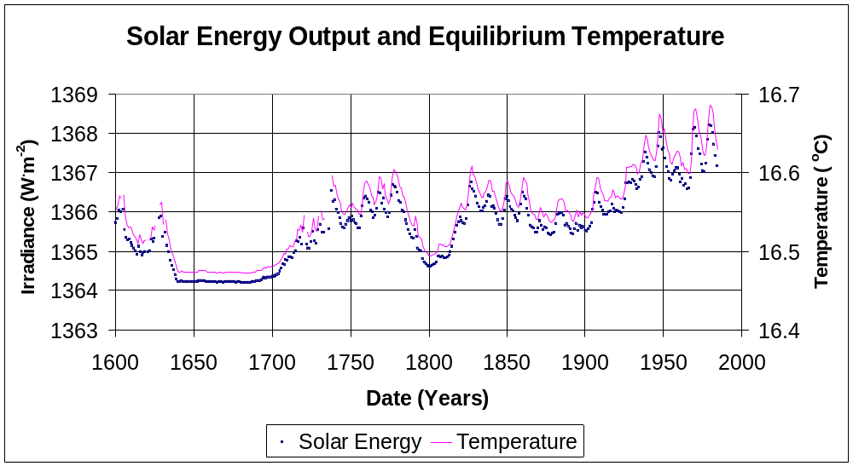

Allow approximately 20 minutes to answer Question 1 (a, b and c).

- (a) How does solar energy input (shown by the dark dots) vary with temperature (light dots) and time?
[5 marks]

  - What can you infer from the graph about possible future climate change?
[5 marks]

  - Suggest what impact a temperature change of two degrees Celsius might have on the Earth.
[8 marks]

Allow approximately 10 minutes to answer question 2.

- Compare and contrast the chemical and physical properties of the rocks contained in the continental crust, oceanic crust and mantle. Limit your discussion to igneous rock groups. Use diagrams to show where these rock types are found.
[8 marks]

Allow approximately 10 minutes to answer question 3 (a and b).

3. (a) The diagram below illustrates a cross-section of an active tectonic margin.

Name and describe the three tectonic environments (A, B & C) indicated in the diagram and give a predominant rock type found in each environment.
[6 marks]
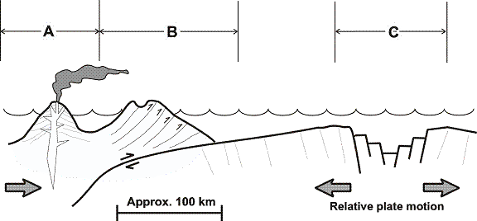

Description
A
Tectonic environment
A
Predominant rock type
B
Tectonic environment
B
Predominant rock type
C
Tectonic environment
C
Predominant rock type

- Relate the location of the major earthquake zones shown on the map below to movement within the Earth.
[4 marks]

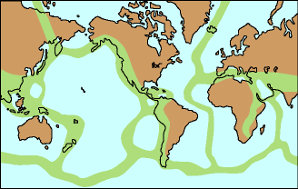

Allow approximately 10 minutes to answer question 4.

The northern expansion of the Perth metropolitan area has meant that most of the rural industries such as market gardens (growing vegetables), poultry farms and wineries have been forced to relocate due to housing developments.

The local council has decided to rezone an area north of Two Rocks for rural use. Currently the area is natural scrubland with medium density vegetation and various marsh areas with one large lake in the vicinity. The lake is the centre of a richly diverse ecosystem including fish, frogs, snakes and some rare small marsupial species.

The soil in the area is very sandy with only a modest nutrient value; therefore market gardens will be dependent upon heavy use of fertilisers. Bores will supply the water needed to operate the market gardens.

4. Identify at least four recommendations you would make to the local council to minimise the impact of the rezoning. Explain the reasoning behind your recommendations.
[8 marks]

Allow approximately 10 minutes to answer question 5.

Groundwater resources of the Swan coastal plain, Perth.

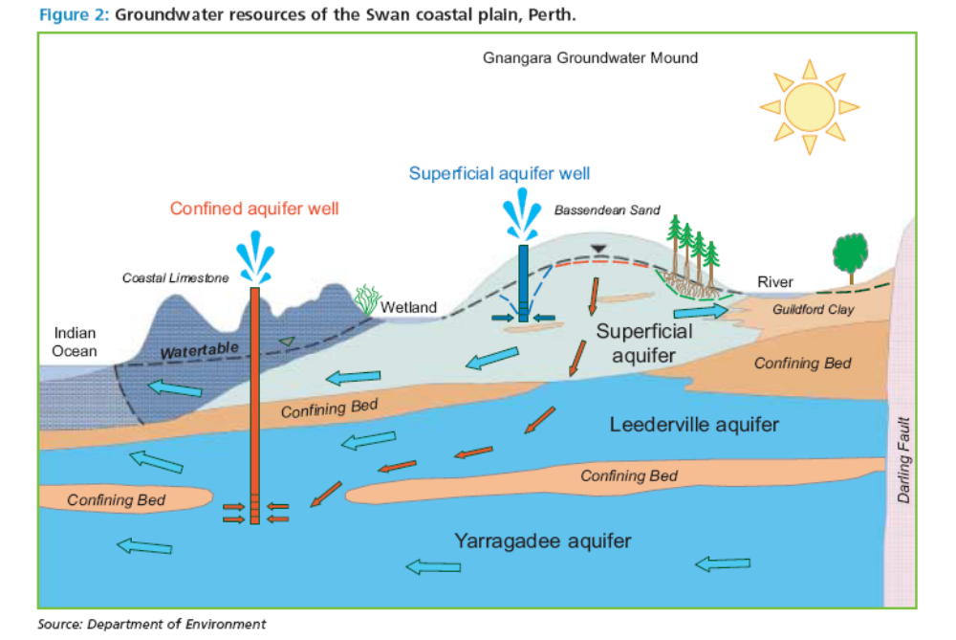

Answer question 5 with reference to the diagram and the contexts that you have studied.

5. Since 1998 the Water Corporation has accessed water from the Yarragadee aquifer as a drought contingency measure.
Discuss the impact of drawing water from this confined aquifer if extraction does not occur sustainably.
[8 marks]

Allow approximately 20 minutes to answer question 6 (a and b).
6 (a) Explain, with the aid of diagrams, the geological formation of a mineral deposit or natural resource that you have studied. Name your deposit or resource.
[8 marks]

6 (b) Explain four environmental impacts that are likely to be associated with the development of a mine site for a mineral deposit or natural resource that you have studied.
[10 marks]

Type of deposit/natural resource___________________________________________

Allow approximately 15 minutes to answer question 7.

Graph 1:
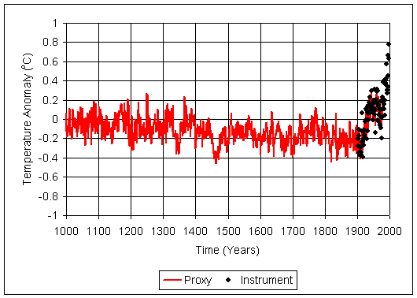
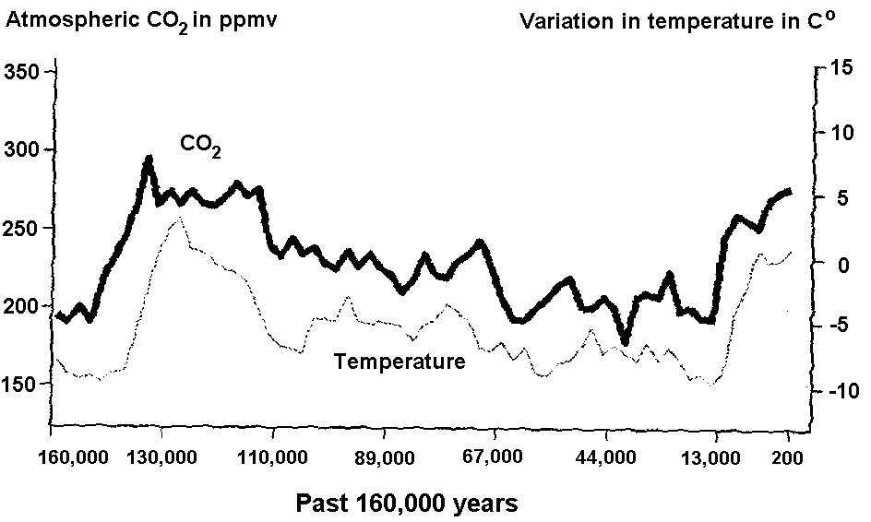

Graph 2:

Paleoclimatologists gather proxy data from natural recorders of climate variability such as tree rings, ice cores, fossil pollen, ocean sediments, corals and historical data. By analysing records taken from these and other proxy sources, scientists can extend our understanding of climate far beyond the 100+ year instrumental record.
(NOAA)

- Compare and contrast the data available from the two graphs. Be sure to include the relationships between temperature, time and CO₂ concentration and any links to the enhanced Greenhouse effect.
[12 marks]

Allow approximately 15 minutes to answer question 8.
8. A soil scientist has asked for your assistance to investigate the way in which soils vary between the coast and 30 km inland. The properties that are of interest are pH levels, salinity, CaCO₃ content, organic content and clay content.
For two of these properties you are asked to propose an hypothesis and the procedures you would use to test this hypothesis. Your answer should include the sampling methods, controls and testing methods used.
[10 marks]

SECTION 2: Extended Answer

This section contains 2 questions. Attempt both questions. Write your answers in the spaces provided.

Allow approximately 70 minutes for this section of the paper.

9. Geohazards
Geoscience Australia has been involved in geophysical monitoring and earthquake hazard assessment for more than 60 years. The program spans a comprehensive range of scientific activities including monitoring of natural hazards in the Australia region (mainly earthquakes, landslides, tsunamis, volcanic events, sea level rise and geomagnetic storms) and research into the nature, origin, and occurrence of the hazards themselves. Four recent examples of significant geohazards are the Boxing Day tsunami of 2004, the Kashmir, India October 2005 earthquake (7.6 magnitude), the Honshu, Japan November 2005 earthquake (7.2 magnitude) and the eruption of Ulawun volcano, Papua New Guinea March 2006.
(Geoscience Australia)

Select and discuss a significant geohazard occurrence. In your discussion:
- explain the geology associated with the geohazard
- describe how this type of natural hazard is monitored
- evaluate the local and global impact of the geohazard.
[20 marks]
10. Biodiversity
For copyright reasons this text cannot be reproduced in the online version of this document—it is available in the hard copy version, and can be viewed on the Mass Extinction Underway website at http://www.well.com/~davidu/extinction.html [paragraph under ‘The Current Mass Extinction’].
Discuss the current biodiversity crisis. In your response:
- describe what is meant by a mass extinction event and the conditions or events that lead to mass extinction
- explain why the current loss of biodiversity can be viewed as a mass extinction event
- compare and contrast this mass extinction event with a previous one, such as that of the Cretaceous –Tertiary event.
[20 marks]

END OF PAPER
Check that you have written your Student Number on the front cover of this booklet.

This space has been provided for additional workings

ACKNOWLEDGEMENTS

SECTION 1

Question 1: Graph from: Ribbe, J. (n.d.). Example 1: Global temperature. In Mathematical modelling of climate [PowerPoint slide 16]. Retrieved April, 2006, from University of Southern Queensland website: http://www.usq.edu.au/users/ribbe/Modelling%20of%20Climate.ppt#274,16,Example%201:%20Global%20Temperature

Question 3 (b): Diagram from: Kansas Geological Survey. (1999). Principal earthquake zones of the earth. Retrieved April, 2006, from http://www.kgs.ku.edu/Extension/image/earthquake2.html
All rights reserved.

Question 5: Department of Environment. (n.d.). Groundwater resources of the Swan coastal plain, Perth [Diagram]. Perth: Author.

Question 7: Graph 1
Global Commons Institute after Jouzel et al. (1997). Past 160,000 years. In How far and how fast? The critical issue of speed and scale—illustrated by the case of global warming (fig. 1). Retrieved April, 2006, from Green Innovations Inc. website: http://www.green-innovations.asn.au/how-far-how-fast-greenhouse-case.htm

Graph 2
Ribbe, J. (n.d.). Example 1: Background. In Mathematical modelling of climate [PowerPoint slide 9]. Retrieved April, 2006, from University of Southern Queensland website: http://www.usq.edu.au/users/ribbe/Modelling%20of%20Climate.ppt#274,16,Example%201:%20Background

Text
Extract from: National Oceanic & Atmospheric Administration (NOAA), (2002). Introduction to paleoclimatology: Paleo proxy data. Retrieved April, 2006, from http://www.ncdc.noaa.gov/paleo/primer_proxy.html

Question 9: Text adapted from: Geoscience Australia. (2005). The geohazards program. Retrieved April, 2006, from http://www.ga.gov.au/urban/factsheets/index.jsp#program
© Commonwealth of Australia 2006.

Question 10: Text from: Ulansey, D. (2006). Mass extinction underway [The current mass extinction]. Retrieved April, 2006, from http://www.well.com/~davidu/extinction.html
Published by the Curriculum Council of Western Australia
27 Walters Drive
OSBORNE PARK WA 6017

